**RELIGIOUS FESTIVAL (WEB PROJECT)**

**DOCUMENTATION:**

**Requirement Specification:**

The Web site is to be created based on the following requirements.

1. Practice step by step i.e. laddered approach.
2. Build a larger more robust application.
3. Usage of certain utilities in applications designed by user.
4. Single program to unified code leading to a complete application.
5. Learn implementation of concepts in a phased manner.
6. Enhance skills and add value.
7. Work on real life projects.
8. Give a real life scenario and help to create applications more complicated and useful.
9. Mentoring through email support.

**WEB PAGES:**

There seven web pages containing different data of festival:

**1)Home:**

1. consists of slider with animation
2. cards with information about upcoming festivals.
3. Blog contain diffenent festival data

**2)** **Abous us:**

1. About store
2. About services
3. About different terms and contidtions

**3)Religious:**

1. Islam
2. Hinduism
3. christianity

**4)Contact us:**

1. Form
2. Map
3. Address
4. Phone
5. Email

**HOME PAGE**

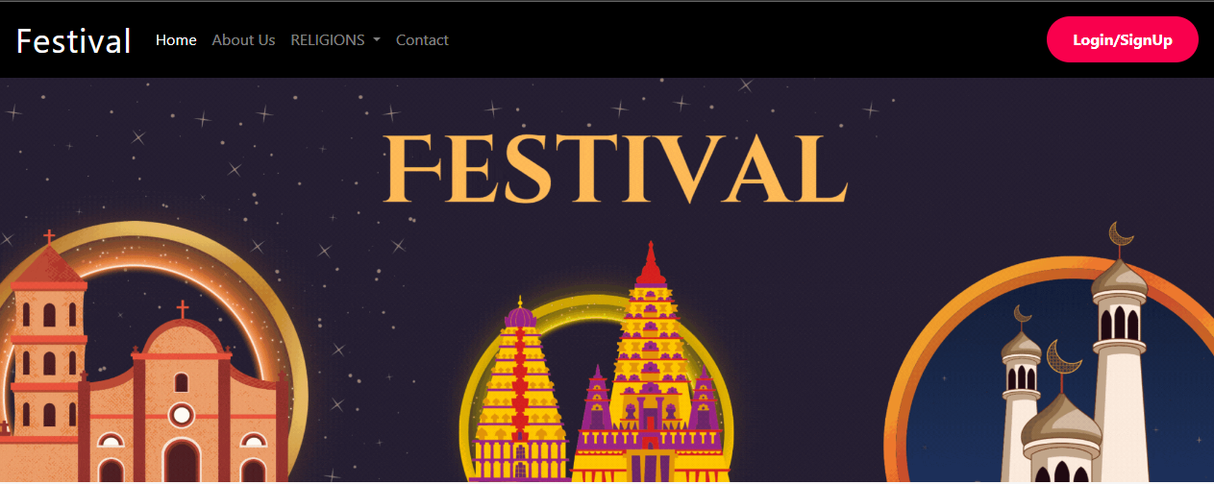

Home page in which there are slides which have different religious festivals information and images with animation. The slide can work manually and automatically. The images are changed automatically after a time which is inserted.

First slide:

In our first slide there is Muslim religious festival.

Second slide:

In our second there is Hinduism religious festival.

Third slide:

In our third there is Christianity religious festival.

**Religious:**

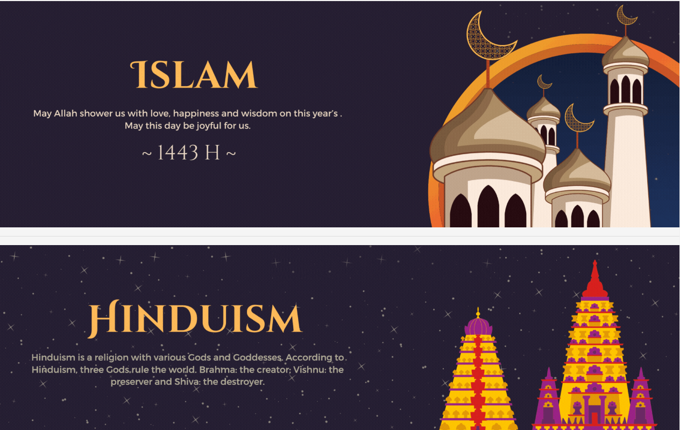

Different buttons of upcoming event with detail.

* First two cards in which there is information about islamic festival
* second two cards in which there is information about hinduism.
* third two cards in which there is information about christianity.

**OUR BLOG**

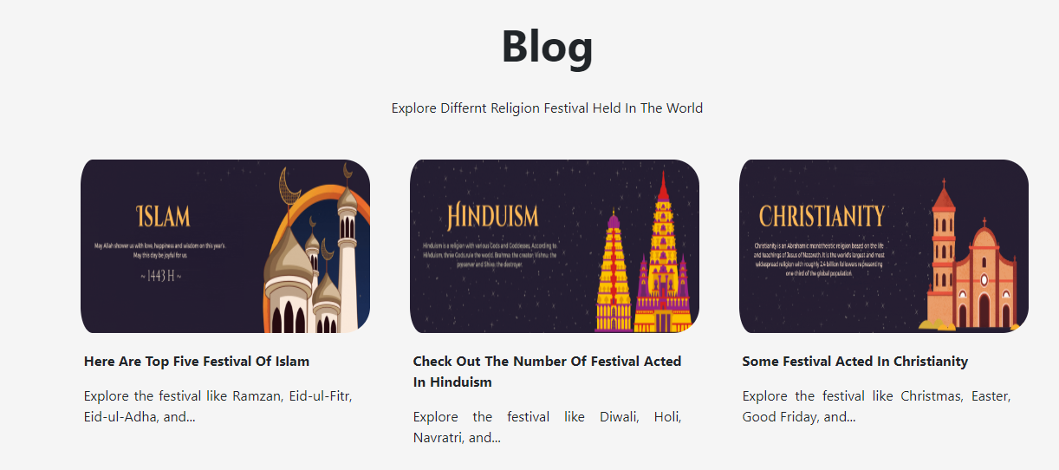

**Ramadan event:**

Ramadan, the ninth month of the Islamic calendar, is one of the most sacred times for Muslims. During this month, Muslims observe a strict daily fast from dawn until sunset. They are not allowed to eat or drink, not even water, during these daylight hours.

**Happy Diwali:**

Diwali: Festival of Lights. In India, one of the most significant festivals is Diwali, or the Festival of Lights. It's a five-day celebration that includes good food, fireworks, colored sand, and special candles and lamps.

**Happy Christmas:**

Christmas is a Christian festival that celebrates the birth of Jesus Christ, who Christians believe was the son of God. For most people, it takes place every year on 25 December – the day that the Roman Catholic Church chose to mark Jesus' birthday.

**ABOUT US**

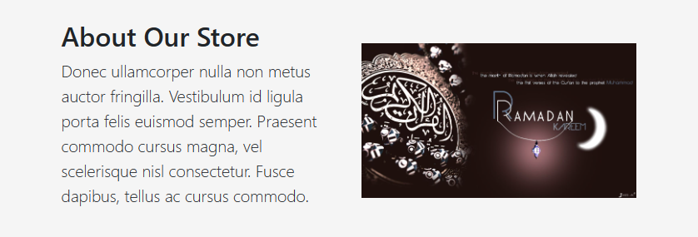

**SERVICES**

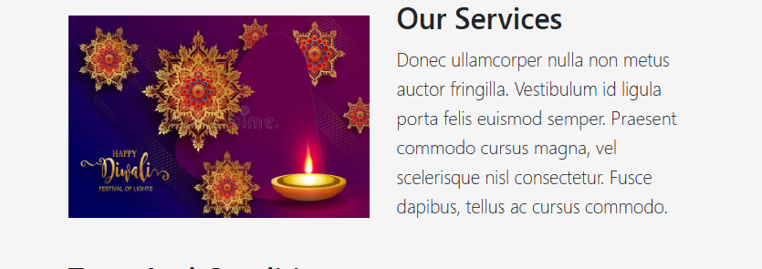

**TERM AND CONDITION**

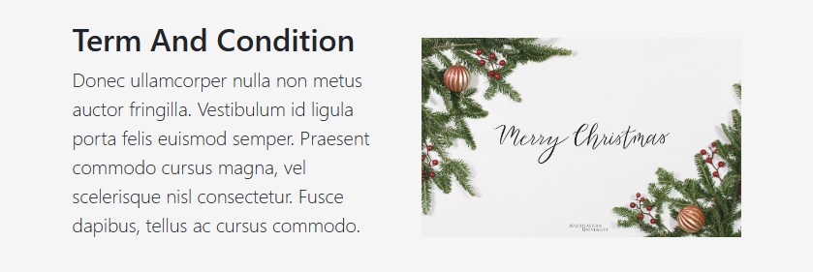

**ISLAMIC FESTIVALS**

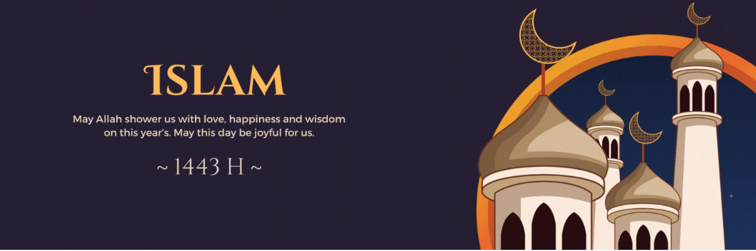

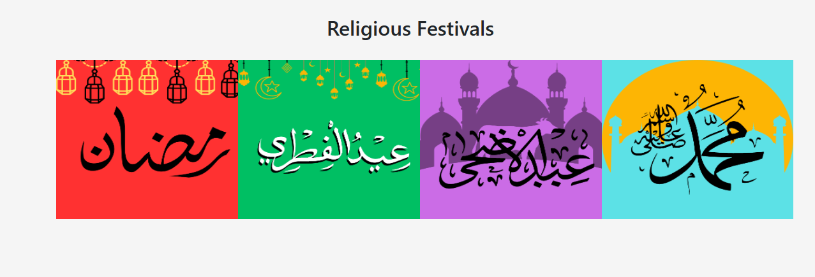

**DIFFERENT EVENTS**

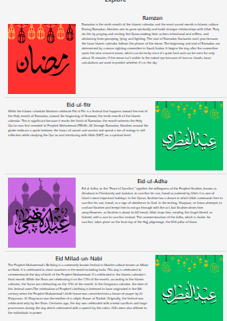

**HINDUISM**

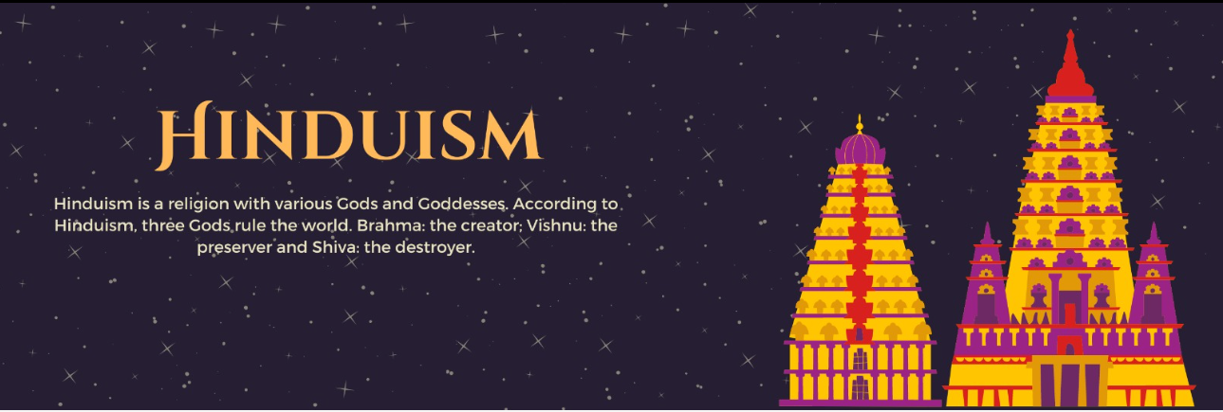

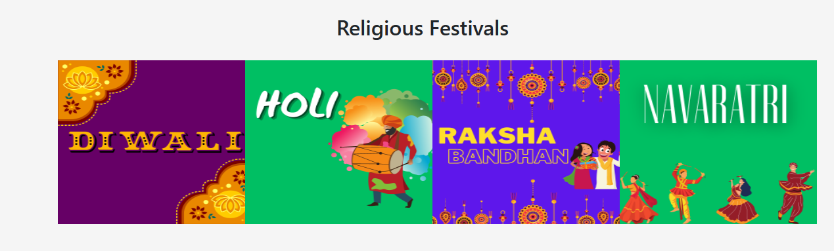

**DIFFERENT EVENTS**

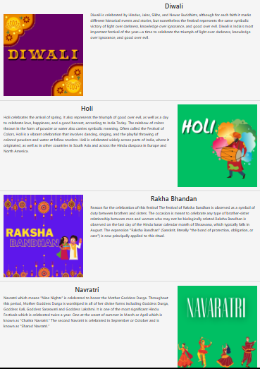

**CHRISTIANITY FESTIVALS**

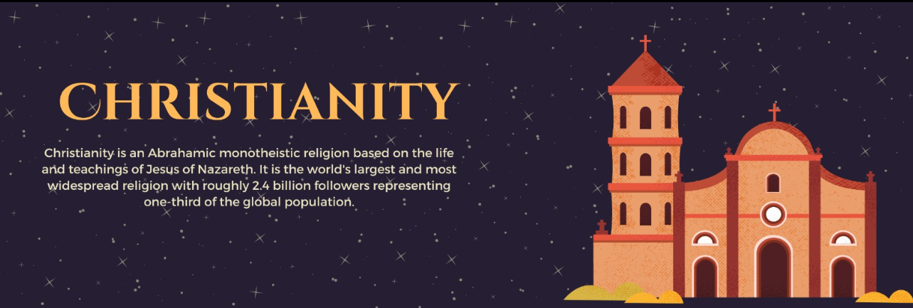

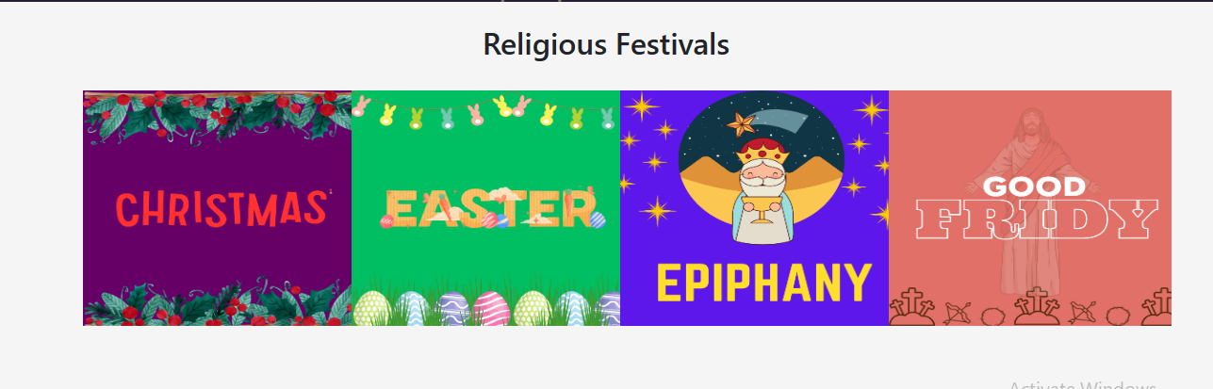

**DIFFERENT EVENTS**

pp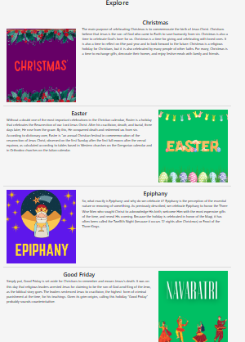

**FORM**

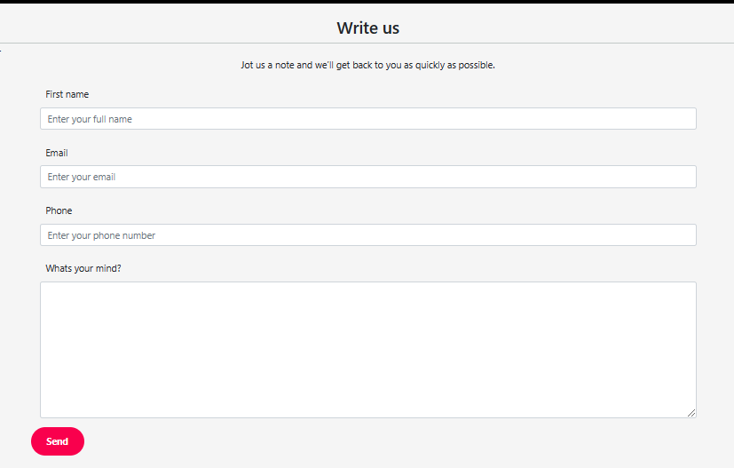

There is form in which you can insert youe name,email,phone number and enter your personal feedback and send it .

**INFORMATION**

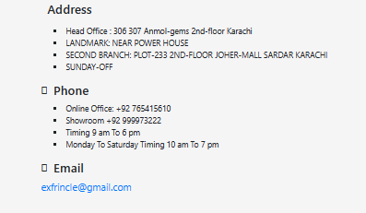

Information for client to reach us through address , can phone call and email also.

**MAP**

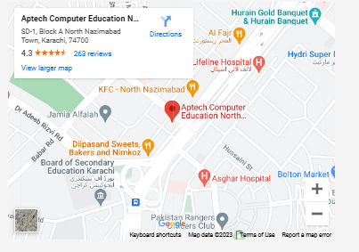

Location of our office please visit our office at giving location.

**SIGN UP**

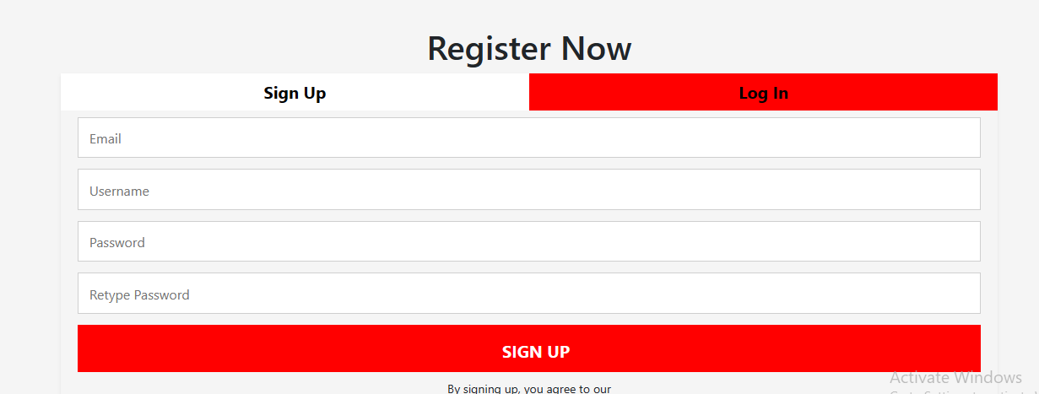

Sign up page for client to make account in website through which you can register yourself.

**GROUP MEMBERS**

|  |  |
| --- | --- |
| **STUDENTS NAME** | **STUDENT EMAIL** |
| Raffay Asim | **raffay.asim6@gmail.com** |
| Imran Saleem | **imransaleem741@gmail.com** |
| Syed Saif Ali | **syedsaif.sharif@gmail.com** |